Self-assessment 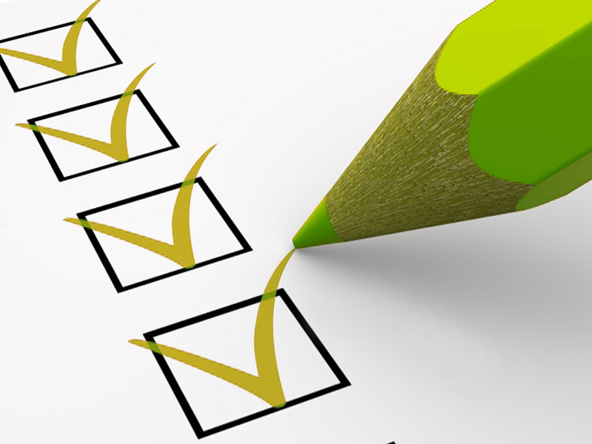
My speech

Self-assessment of my speech

Date
Place
Title
Audience

How did I feel during the presentation?

What have I done very well?

What would I do differently next time?

What did I learn?

Did I connect with the public? How? What did it help you to reach the audience?

Did the public got the message I conveyed?

Have I caught public attention with the introduction?

Was the ending of my speech memorable?

Was the language I use appropriate to the audience?

Did I speak with passion and entusiasm? How did I do it?

Did I keep eye contact with the audience? How?

Did I speak at an appropiate rhythm?

Did I finish the presentation within the allotted time ?

3 strong points of my presentation:

3 weaknesses of my presentation:

Ideas for the next presentation:

